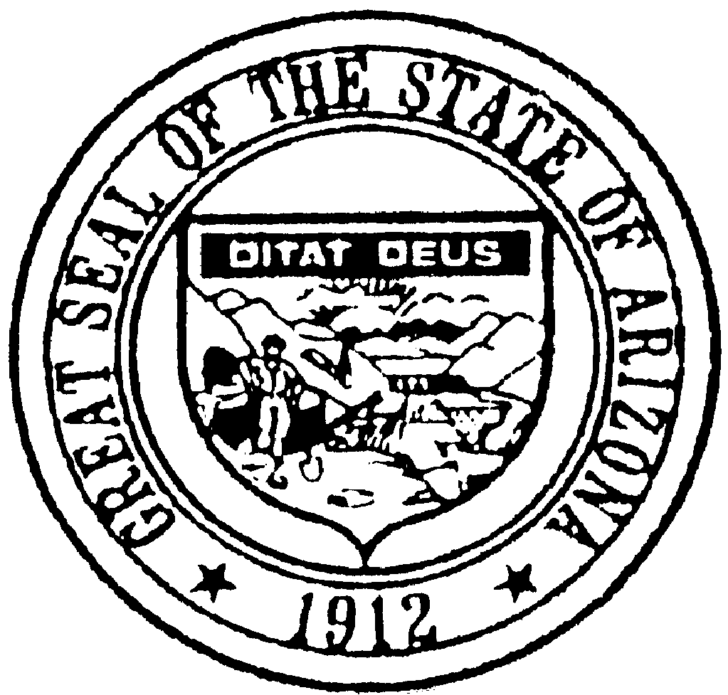
ARIZONA BOARD OF ATHLETIC TRAINING
1740 West Adams Street, Suite 3407
Phoenix, Arizona 85007
(602) 589-6337
www.at.az.gov
Email: at.info@otboard.az.gov

NOTICE AND AGENDA OF THE MEETING OF
THE ARIZONA BOARD OF ATHLETIC TRAINING
NOVEMBER 7, 2018 – SCHEDULED TO BEGIN AT 1:00 P.M.

Pursuant to Arizona Revised Statutes (“A.R.S.”) § 38-431.02, notice is hereby given to the members of the Arizona Board of Athletic Training (“Board”) and the General Public that the Board will hold a Telephonic Board Meeting open to the public on November 7, 2018, beginning at 1:00 p.m. in Conference Room 1024, 1740 West Adams Street, Phoenix, Arizona. A copy of this Agenda is available by writing to the Board’s mailing address. This Agenda is amendable up to twenty-four hours prior to the meeting. The Board reserves the right to change the order of items on the agenda except for hearings set for a specific time.
Pursuant to A.R.S. § 38-431.03(A)(3), the Board may vote to hold an executive session for legal advice on any matter on the agenda. The executive session will not be open to the public.
Persons with a disability may request a reasonable accommodation, such as a sign language interpreter, by contacting (602) 589-6337 or at the TDD number 1-800-367-8939. This document is available in alternate format by contacting (602) 589-6337 or at the TDD number 1-800-367-8939.
AGENDA
- CALL TO ORDER
- ROLL CALL
- DECLARATION OF CONFLICTS OF INTEREST
- REVIEW, CONSIDERATION, AND POSSIBLE ACTION ON APPLICATIONS FOR LICENSURE
The Board may vote to go into Executive Session pursuant to A.R.S. § 32-431.03(A)(2) (to discuss confidential information) or A.R.S. § 38-431.03(A)(3) (to receive legal advice).
  - Renewal Applications – Board Review
    - Josie Harding, ATR-001215 – Reinstatement
    - Nicole Mumaw, ATR-001477 - Reinstatement
- FUTURE AGENDA ITEMS
- CALL TO THE PUBLIC
The Board may make an open call to the public during the meeting, subject to reasonable time, place and manner restrictions, to allow individuals to address the Board on any issue within its jurisdiction. Pursuant to A.R.S. § 38-431.01(H), members of the Board are not allowed to discuss or take legal action on matters raised during an open call to the public unless the matters are properly noticed for discussion and legal action. However, the Board may ask staff to review a matter or may ask that a matter be placed on a future agenda. Public input is encouraged. Presentation should be limited to five minutes.
- ADJOURNMENT

